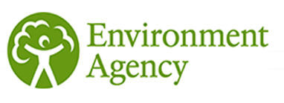**Job Title  
Salary  
Contract  
Location**

**About the Environment Agency**

If you’re part of the Environment Agency, you’re part of the solution. Working with us means protecting and improving the environment for generations to come, tackling issues of national importance across a huge variety of disciplines. Our responsibilities span major industry regulation, flood defences, land contamination, water quality, fisheries, and conservation. Such a broad scope of work calls for diverse, multi-skilled teams and exceptional leadership: together, we’ll promote sustainable growth, tackle climate change, and secure a better future for everyone.

**Your role with us**

(Enter text here to describe the role including purpose, day-to-day tasks, responsibilities etc.)

**Who we’re looking for**

(Enter text here to describe the person you are looking for including skills, capabilities, qualifications and experience required)

**Your benefits with us**

You will benefit from a culture that embraces difference and includes everyone, where you will feel supported and trusted to do the right thing. We will invest in you and allow you to grow and shape your career. What’s more, you’ll be able to have access to our great benefits package, including generous annual leave, an excellent pension, flexible working arrangements and the opportunity to be part of a variety of staff networks.

We are fully committed to having an inclusive workforce to reflect the communities we serve. To achieve this, we welcome applications from all backgrounds regardless of race, sexual orientation, or religion. We also welcome applications for flexible working patterns.

**Apply**